LITTLE HEROES FAMILY BURN CAMP
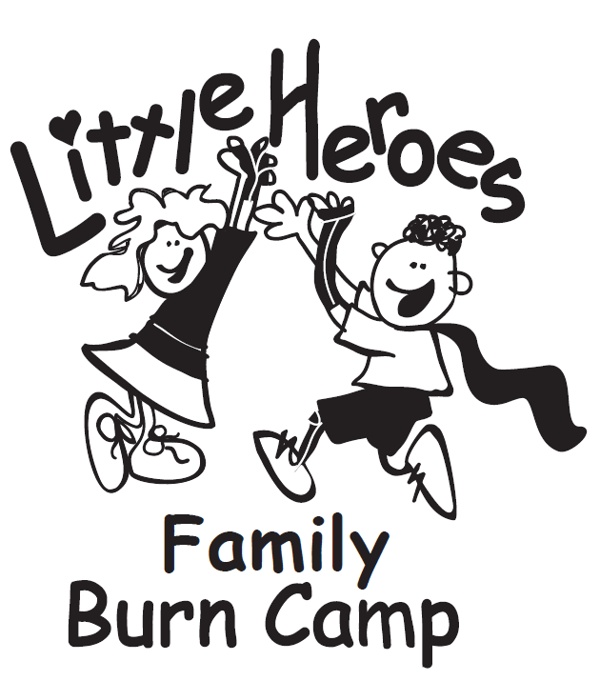
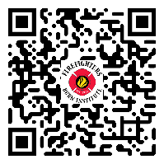
FAMILY APPLICATION
Apply Online: app.campdoc.com/register/ffbi
PLEASE RETURN THIS SIGNED FORM BY September 17, 2024
MAIL TO: Firefighters Burn Institute, 3101 Stockton Blvd., Sacramento, CA 95820
Phone: (916) 739-8525 | Email: valorie@ffburn.org | WEBSITE: www.ffburn.org

CAMP DATES: NOVEMBER 1-3, 2024. Little Heroes Family Burn Camp is a burn recovery program designed for young burn survivors ages 1-6 years old, their siblings and caregiver(s). This unique three-day program empowers children and their families to understand and cope with physical and emotional challenges associated with burn recovery.

PERSONAL INFORMATION

YES NO
PARENT/LEGAL GUARDIAN’S LAST NAME First NAME Burn Survivor

BIRTH DATE TSHIRT SIZE

YES NO
PARENT/LEGAL GUARDIAN’S LAST NAME First NAME Burn Survivor

BIRTH DATE TSHIRT SIZE

YES NO
CHILD’S LAST NAME First NAME NICKNAME Burn Survivor

BIRTH DATE Male/female/non-binary TSHIRT SIZE

CHILD’S PRONOUNS: HE/HIS/HIM SHE/HERS/HER THEY/THEM OTHER: ___________________

YES NO
CHILD’S LAST NAME First NAME NICKNAME Burn Survivor

BIRTH DATE Male/female/non-binary TSHIRT SIZE

CHILD’S PRONOUNS: HE/HIS/HIM SHE/HERS/HER THEY/THEM OTHER: ___________________

YES NO
CHILD’S LAST NAME First NAME NICKNAME Burn Survivor

BIRTH DATE Male/female/non-binary TSHIRT SIZE

CHILD’S PRONOUNS: HE/HIS/HIM SHE/HERS/HER THEY/THEM OTHER: ___________________

YES NO
CHILD’S LAST NAME First NAME NICKNAME Burn Survivor

BIRTH DATE Male/female/non-binary TSHIRT SIZE

CHILD’S PRONOUNS: HE/HIS/HIM SHE/HERS/HER THEY/THEM OTHER: ___________________

fAMILY MAILING ADDRESS CITY sTATE ZIP

HOME PHONE CELL PHONE EMAIL ADDRESS

YES NO
PRIMARY LANGUAGE SPOKEN IN HOMe? Do all members of your FAMILY SPEAK
AND UNDERSTAND eNGLISH?

_________________________________________________________________________________________________________
HOW WERE YOU REFERRED TO THE PROGRAM?

BURN SURVIVOR MEDICAL INFORMATION

/ /
date of child’s burn injury how child was burned

area/s of body burned – hand/torso/leg etc % of body surface

CHILD’S SPECIAL NEEDS (dressing changes, physical therapy, etc. – description to include frequency)

- does your child HAVE ANY PHYSICAL LIMITATIONS? YES NO

if so, please explain (include if they use a wheelchair, etc.): _____________________________________________________________________________________________________

_____________________________________________________________________________________________________

- does your child wear a dIAper? Name? YES NO

- Has your child ever consulted a physician, mental health Provider
or counselor concerning an emotional problem? YES NO

if so, please explain (include last visit date):_____________________________________________________________

_____________________________________________________________________________________________________

QUESTIONAIRE

- does anyone in your family have any dietary restrictions? YES NO

if so, please explain: ____________________________________________________________________________________________________

____________________________________________________________________________________________________

- DOES ANYONE IN YOUR FAMILY HAVE FOOD ALLERGIES? SI NO

if so, please explain REACTION IF EATEN: ____________________________________________________________________________________________________

____________________________________________________________________________________________________

- does anyone in your family have any medical related restrictions that might prohibit him/her from participating in activities, including special education or a learning disability? YES NO

if so, please list: _________________________________________________________________________________

___________________________________________________________________________________________________

- IS ANY FAMILY MEMBER CURRENTLY DEALING WITH ANY SPECIAL ISSUES SUCH AS PEER PRESSURE, A LEARNING DISABILITY, FAMILY ILLNESS, ALCOHOL OR DRUG RELATED USE?: YES NO

if so, please explain: __________________________________________________________________________________________

_________________________________________________________________________________________________________________

- WHAT ARE YOUR CHILD/CHILDren’S FAVORITE ACTIVITIES? ________________________________________________________________

_________________________________________________________________________________________________________________

- Does your chilD/children have separation anxiety? YES NO

if yes, please LIst child/children and extent of anxiety: __________________________________________________________

_____________________________________________________________________________________________________________________

- In what ways do you think we can help your family develope & GROW? ___________________________________________

- is anyone in your family bringING ANY MEDICATIONS to camp? YES NO

(List all medications, including any over the counter meds, and whom they are for. This includes an EpiPen.)

PHOTO / VIDEO RELEASE

During the course of this program your family may be participating in an activity that is being photographed (print or video). These photographs may be used for promotional/educational purposes including posting on social media websites by the Firefighter Burn Institute or our affiliates and sponsors. Your names, child’s cause of burn and any other sensitive information will not be used without further consent.

Yes, I GIVE PERMISSION FOR MY family TO BE PHOTOGRAPHED for promotional/educational purposes.

No, I would prefer that my family not be photographed for promotional/educational purposes.

Parent/LEGAL Guardian’s Signature DATE

TRANSPORTATION

Transportation will be provided from the following locations. Check your anticipated travel mode. You will be contacted prior to camp to make the final arrangements. If providing own transportation, please arrive at camp no later than 4:30pm on Friday and depart no later than 12:30pm on Sunday.

Angel flight-California/western NV/southern OR  Angel flight | WILL PROVIDE our OWN TRANSPORTATION
Commercial flight to sacramento – ffbi providing pick up and drop off from airport to camp location and back on 11/1 and 11/3  Angel flight | OTHER:______________________________________

IF EXPLANATION NEEDED, PROVIDE HERE: _________________________________________________________________

EMERGENCY INFORMATION

( )
EMERGENCY CONTACT RELATIONSHIP PHONE

( )
EMERGENCY CONTACT RELATIONSHIP PHONE

In the event of an emergency, I hereby give my permission to the Little Heroes Family Burn Camp medical staff to secure and administer treatment at my expense, including emergency medical or surgical treatment as may be necessary (including, but not limited to x-rays, routine tests, treatment and necessary related transportation).

Parent/LEGAL Guardian’s Signature DATE

PARTICIPATION AGREEMENT

All participants will be required to adhere to the following rules. Failure to follow these rules may lead to removal from camp.
- Attendees will be required to follow all camp/campsite related rules at all times.
- Attendees will be respectful of all other attendees, staff and camp employees. This includes harassment in any manner… profanity, racial, sexual, physically threatening, etc.
- Parents/guardians will take responsibility for the actions of their children.
- Possession of illegal drugs, alcohol, weapons or firearms will not be tolerated.
- Attendees will be expected to protect the environment by disposing trash properly and returning items to where they belong (“leave no trace”).
- Attendees will release and hold harmless the Firefighters Burn Institute, all affiliated organizations, volunteers, representative and sponsors from any civil, property or related damages and expenses (including attorney fees) that may occur due to my participation in Little Heroes Family Burn Camp and its activities.
I have read and agree to these terms and conditions:

Parent/LEGAL Guardian’s Signature DATE

GROUP STUDY RELEASE

We will be conducting a survey to determine how the camp experience has enriched your family’s life. The results of this study will help us plan and improve future programs.

Yes, we are willing to participate.

No, We would prefer not to be contacted.

Parent/LEGAL Guardian’s Signature DATE

PARENT/CAMPER QUESTIONS & CONCERNS

Please use this area for any questions or concerns. Include any information you would like camp staff to be aware of.

COVID-19 STATEMENT

I understand that the Firefighters Burn Institute will follow all federal, state, and local guidelines to the best of its ability surrounding COVID-19 for the duration of camp. Measures to be followed include, but are not limited to, wearing face coverings, requiring proof of vaccination, and/or proof of a recent negative PCR or rapid COVID test or tests. A positive test may result in exclusion from the remainder of camp. FFBI will not provide transportation for a staff member or camper family that tests positive for COVID-19.

Parent/LEGAL Guardian’s Initial acknowledgement DATE

